VISUAL PROGRAMMING LAB 7

TOPIC:
DEPENDENCY INJECTION IN BLAZOR

NAME:
MUHAMMAD TALHA
SECTION:
4/A
ROLL NUMBER:
241890

INSTRUCTOR:
MS. AMNA TARIQ

Lab task#1
Salary Calculation Service
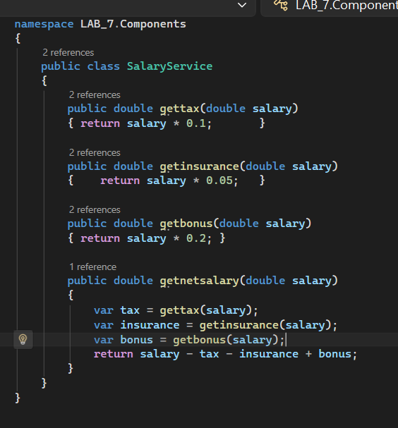

Blazor component
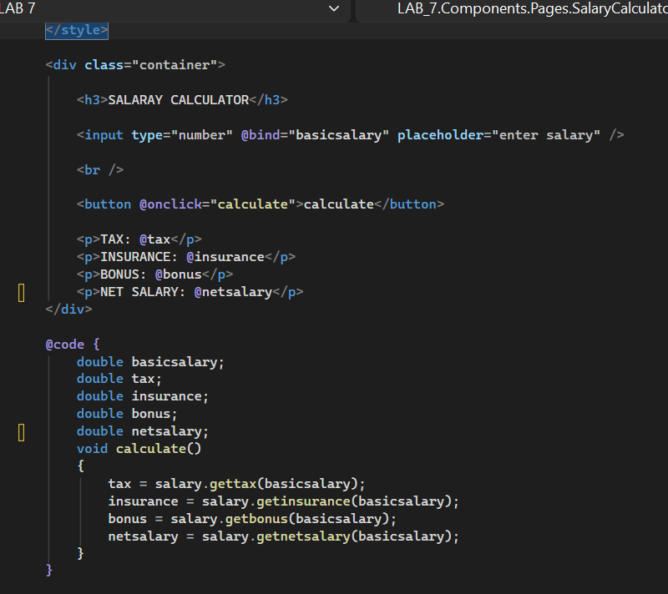

Results:
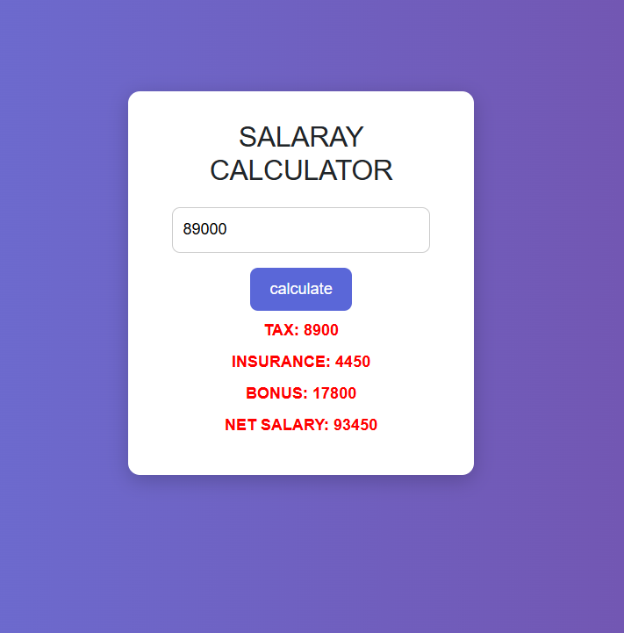

LAB TASK #2
Blazor list of elements App
Service:
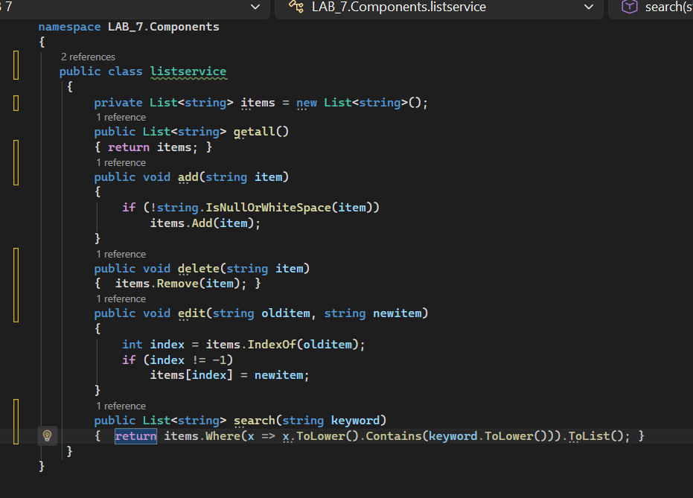

Razor Components:
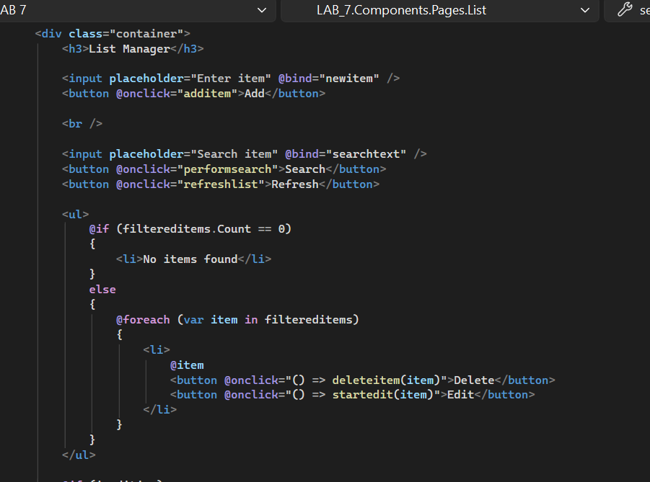
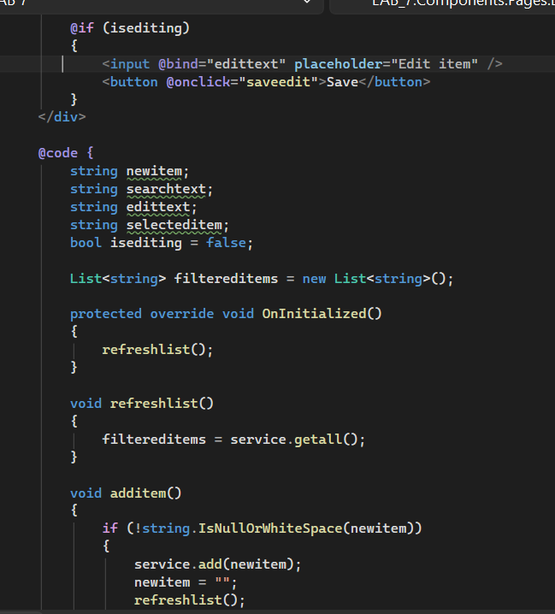
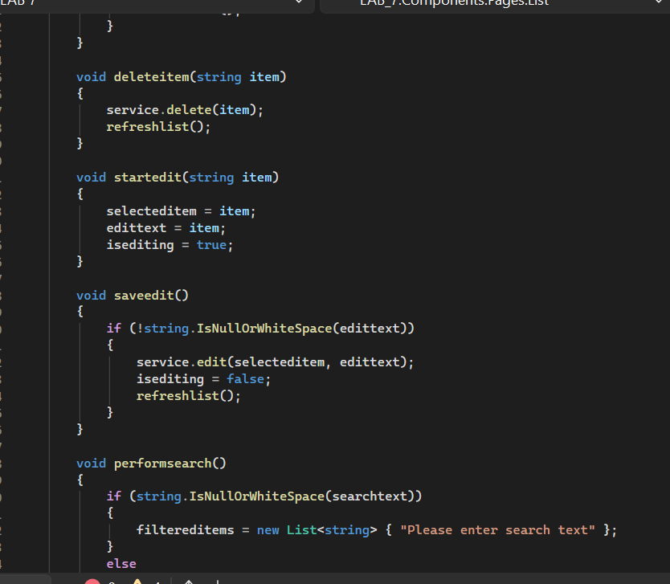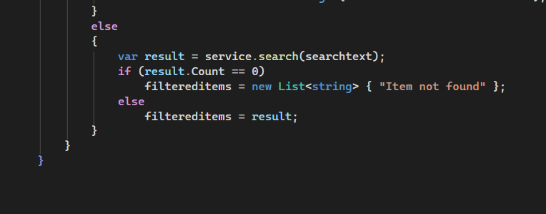

Results:
